 | Year 12 Methods  TEST 3 7 June 2019  TIME: 45 minutes working  Calculator Assumed  44 Marks 6 Questions

Name: _______________________________ Teacher: ___________________________
Note: All part questions worth more than 2 marks require working to obtain full marks.
Question 1 (5 marks)
- Differentiate $x\sin{x}$ (2 marks)
Solution
Specific behaviours
uses product rule
obtains derivative

- Hence find $\int_{0}^{\frac{π}{2} }{x\cos{x dx}}$ using the result in(a) above. (3 marks)
Solution
Specific behaviours
integrates equation in (a)
uses fundamental theorem
uses limits correctly to obtain exact result

Question 2 (3 marks)
Determine the x-coordinates of all points on the graph of $f\left(x\right)=2\cos\left(x\right)+x$ for $-π≤x≤ π$ where the tangent line is horizontal. (Justify your answers)
Solution
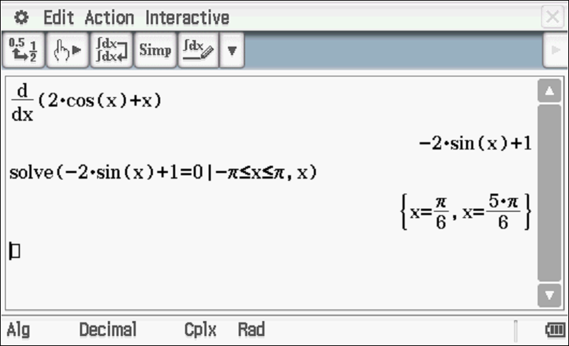
Specific behaviours
differentiates(must be stated)
equates derivative to zero
solves for exact x coordinates within required domain

Question 3 (7 marks)
A survey conducted by a local bank shows that 75% of its customers use an ATM at least once a month.
- Find the probability that in a random sample of 8 customers, at least 75% of them use an ATM machine at least once a month. (2 marks)
Solution
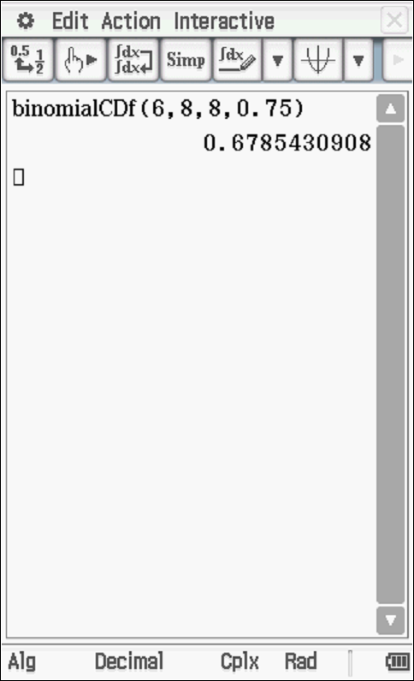

Specific behaviours
uses binomial parameters and at least 6 successes out of 8
states probability

- If the random variable X follows a binomial distribution with n=12 and p=0.75, what is the mean of this distribution and what is P$($X$≥$mean$)$? (3 marks)

Solution
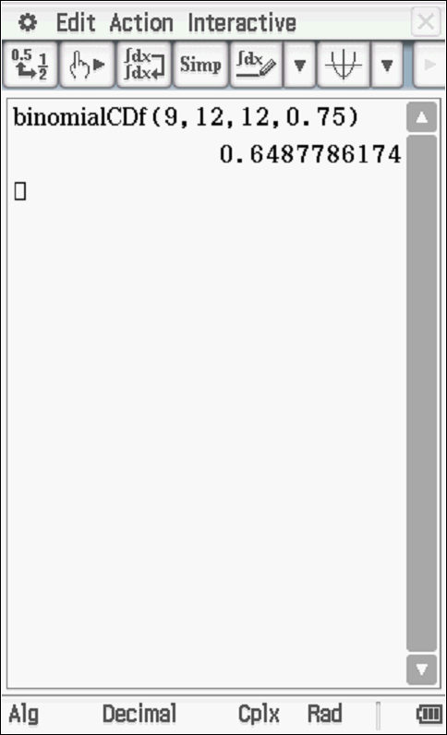
Specific behaviours
calculates mean
uses binomial parameters
states probability

- If the sample size became very large what would you expect P($X ≥$ mean) to approach? Briefly explain your answer. (2 marks)

Solution
As sample size becomes larger, the distribution becomes more symmetrical about the mean, approaching a probability of 0.5.
Specific behaviours
states approaching 0.5
describes the ideal shape of distribution as sample size becomes very large

Question 4 (10 marks)
The discrete random variable X can only take the values 2, 3 or 4. For these values the cumulative distribution function is defined by
for $x = 2, 3 and 4$, where $k$is a positive constant integer.
- Find the value for $k.$ (3 marks)

Solution
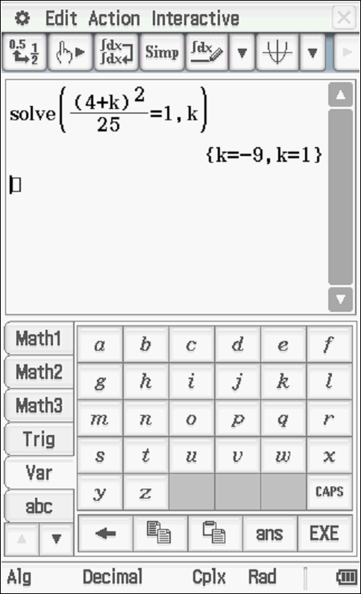
K equals 1 as k is positive.
Specific behaviours
uses
sets up equation for k
solves for k and states only a positive value.

- Complete the following table for X. (3 marks)

Solution
$$X$$ | $$2$$ | $$3$$ | $$4$$
$$P(X≤x)$$ |  |  | 1
$$P(X=x)$$

Specific behaviours
sum of second row equals one
all entries correct

- Hence find $E(X)$ and $SD(X)$. (2 marks)

Solution
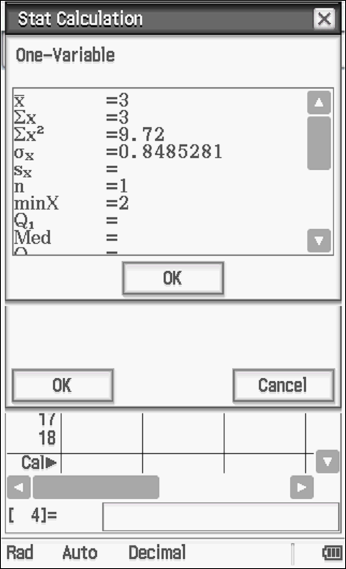
Specific behaviours
states mean
states standard deviation

- Calculate $Var\left(3-2X\right)$ giving your answer to two decimal places. (2 marks)

Solution
Specific behaviours
multiplies old variance by positive 4
rounds to 2 decimal places (only pay this if working is shown for new variance)

Question 5 (8 marks)
Consider the function where is in radians.
- Sketch on the axes below for on the axes below.
Clearly label undefined points (if any). (3 marks)

Solution
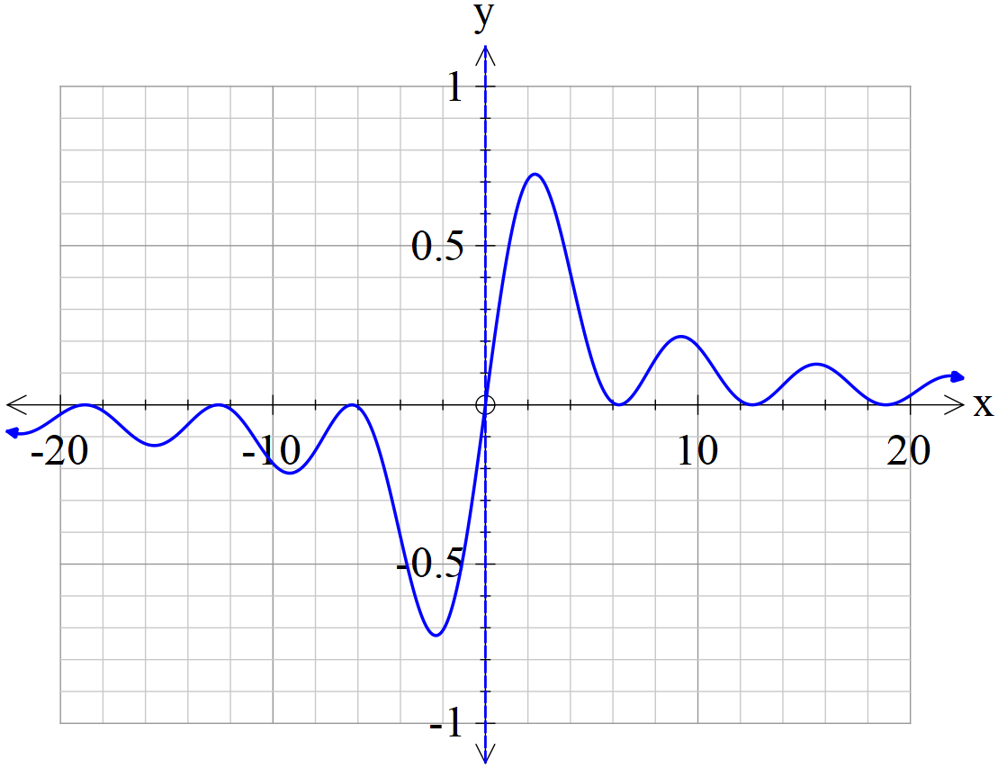

Specific behaviours
shape
open hole at origin or stated undefined at origin
accuracy with intercepts (within 0.1)

- As approaches zero from the positive side, state the value that approaches.
(1 mark)

Solution
Approaches zero
Specific behaviours
states approaching zero

- As approaches zero from the negative side, state the value that approaches.
(1 mark)
Solution
Approaches zero
Specific behaviours
states approaching zero

- Use the above to define a value for as approaches zero, that is the following limit . (1 mark)
Solution
equals zero
Specific behaviours
states equals zero

It can be shown that .
- Using the fact that and the above results, show that .
(2 marks)
Solution
Specific behaviours
uses values of both limits
shows that derivative simplifies to required result

Question 6 (11 marks)
A game is played by throwing two standard six-sided dice into the air once. The sum of the uppermost numbers are added together and if the sum is greater than 8 the player wins $5.
Determine:
- the probability of winning $5 in one game. (2 marks)
Solution
 | 1 | 2 | 3 | 4 | 5 | 6
1 | 2 | 3 | 4 | 5 | 6 | 7
2 | 3 | 4 | 5 | 6 | 7 | 8
3 | 4 | 5 | 6 | 7 | 8 | 9
4 | 5 | 6 | 7 | 8 | 9 | 10
5 | 5 | 7 | 8 | 9 | 10 | 11
6 | 7 | 8 | 9 | 10 | 11 | 12

Specific behaviours
recognises that there are 36 outcomes
states prob (no need to simplify)

- the probability of winning exactly $15 in 5 games. (3 marks)

Solution
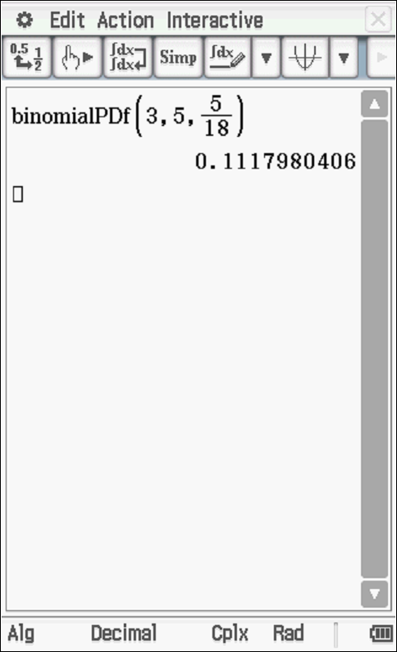
Specific behaviours
states Binomial
uses parameters
states prob

- the probability of winning at least $15 in at most 5 games. (3 marks)
(assume that

Solution

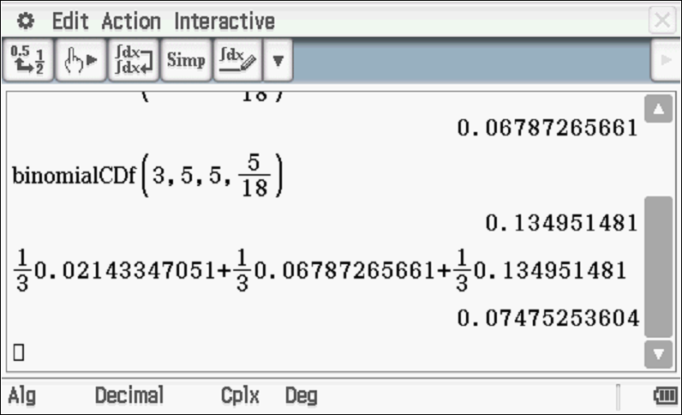
Specific behaviours
examines 3 games with correct parmeters binomialCDf
examines 4 and 5 games and cumulative values
states final prob

- the minimum number of games to be played so that the probability of winning at least $15 is greater than 0.47. (Justify) (3 marks)
Solution
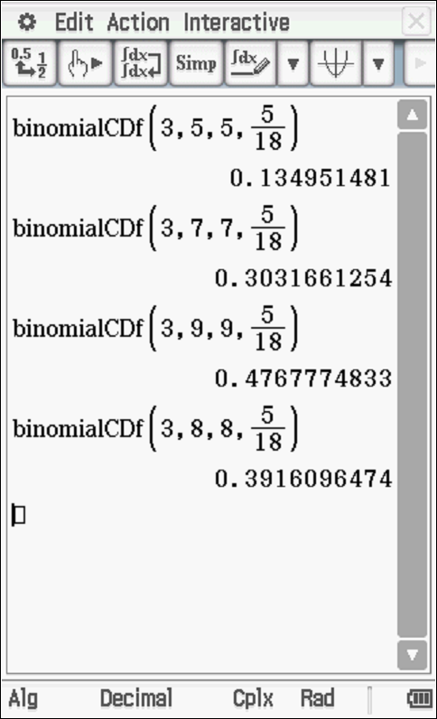
Min number of games is 9
Specific behaviours
uses cumulative Binomial with correct parameters
shows at least 3 sets of trials
demonstrates that 9 games is the minimum

